In [1], [2], it is investigated that as a mechanical switch, a reed switch could produce noise spikes which yield wrong edge detections by a microcontroller, thus wrong data. For example, Figure 1 illustrates a noise instance which could make a microcontroller read 3 falling edges instead of an expected 1 edge within a window of 98.98µs.

|  |  |
| --- | --- |
|  |  |

Figure 1. “An instance of noise spikes captured in an oscilloscope” [1]

The solution to a such problem is the implementation of either a LPF to filter out the noise [2] or just a bypass capacitor to debounce the switch. Due to lower edge rise and fall time, and less components involved, the latter is a more preferable method [1]. The choice for a such capacitor is to satisfy that the time constant of the pull-up resistor – bypass capacitor pair is about half of the debouncing time [3].

|  |  |
| --- | --- |
| $T=R ×C$ where | $T$ (in seconds) is the time constant of the resistor – capacitor pair, |
| $R$ (in Ohms) is the value of the pull-up resistor of the switch circuit, |
| $C$ (in Farads) is the value of the decoupling capacitor. |

It is studied that reed switches have bounces up to 4.5ms. Moreover, in section [3.3.1.1.1], the pull-up resistor for interfacing the anemometer with the microcontroller is chosen to be 33kΩ. Therefore, the value of the bypass capacitor is $C= \frac{T}{R} = \frac{{4.5ms}/2}{33kΩ}=68.18nF$. Since a such value does not exist in real life, the closest value of 68nF is chosen for the bypass capacitor instead.

Furthermore, the fact that section [3.3.1.1.1] determines the pull-up resistor to be 33kΩ relies on the calculation of the bypass capacitor in this section. The bypass capacitor value is derived from a list of manufactored resistor values, which should be available for both testing and prototyping when this thesis is conducted, and is picked from the closest real numbers for a capacitor. Table 1 shows that the resistor – capacitor pair of 33kΩ – 68nF fits the theoratical calculation the most.

|  |  |  |
| --- | --- | --- |
| Real resistor value | Calculated capacitor value | Closest real capacitor value |
| 30kΩ | 75.00nF | 82nF |
| 33kΩ | 68.18nF | 68nF |
| 36kΩ | 62.50nF | 68nF |
| 39kΩ | 57.69nF | 56nF |
| 47kΩ | 47.87nF | 47nF |

Table 1. Choosing bypass capacitor value based on available resistors from 30kΩ to 50kΩ

In order to determine the practicability of the pull-up resistor and the bypass capacitor, a circuit illustrated in Figure 2 is put in use. The reed switch stays attached inside the anemometer and is read from the corresponding pins of the RJ11 connector. The smoothed-out transitions shown in Figure 3 are consistent with the findings in [1] and indicate that the setup is applicable in a real design.

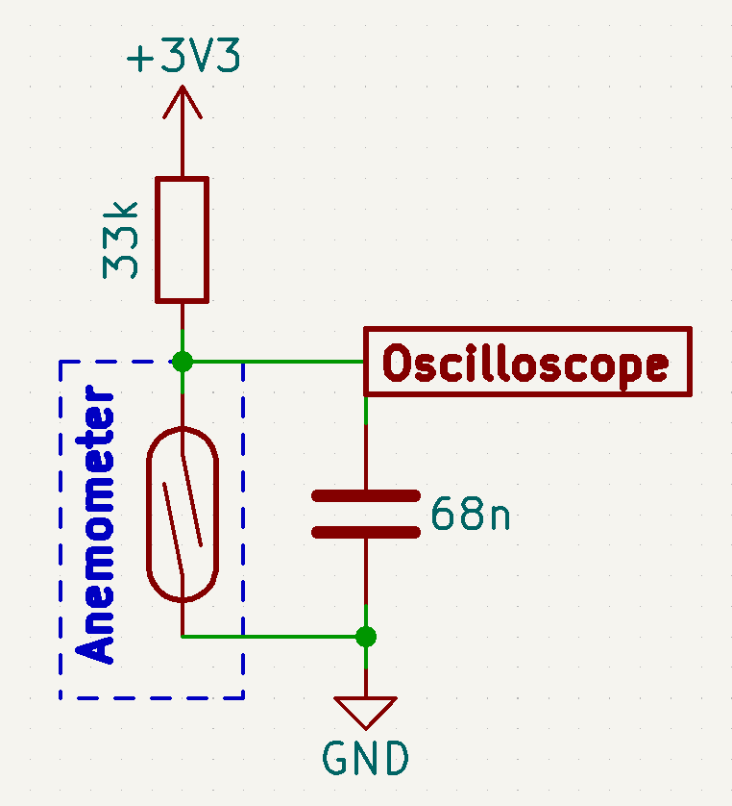

Figure 2. Bypass capacitor test circuitry using the reed switch from the anemometer

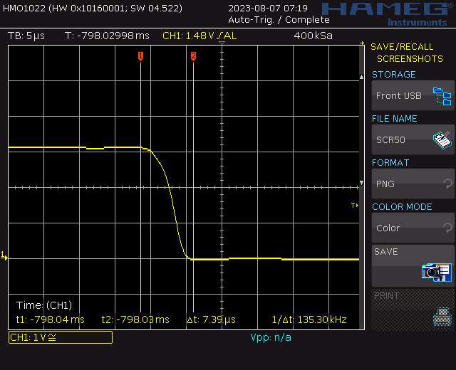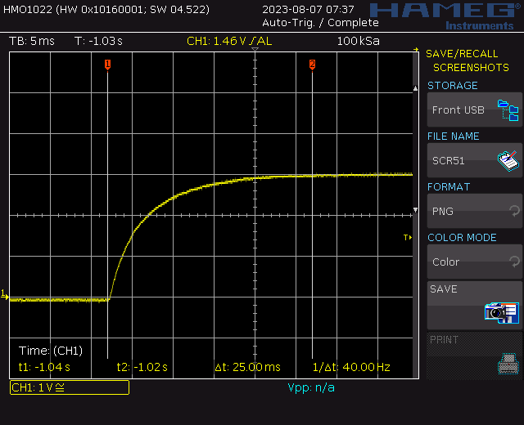

Figure 3. Reed switch debounced by the bypass capacitor

[1] H. N. Do, “Conceptual Design of an Autonomous Wireless Agrometeorology Station,” 2023.

[2] J. Christoffersen, “Switch Bounce and How to Deal with It,” *All About Circuits*, 2015. https://www.allaboutcircuits.com/technical-articles/switch-bounce-how-to-deal-with-it/.

[3] Texas Instruments, “Debounce a Switch.” 2020.